Computer graphics lab manual

Department of computer science and engineering

Year 2019-20

**1. Program to implement Mid Point Line Algorithm. The line coordinates should be specified by the user.**

#include <GL/glut.h>

#include <stdio.h>

int x00,y00,x01,y01;

void init()

{

glClearColor(1,1,1,1);

glClear(GL_COLOR_BUFFER_BIT);

glMatrixMode(GL_PROJECTION);

gluOrtho2D(-500,500,-500,500);

}

void writepixel(int x,int y)

{

glPointSize(5);

glBegin(GL_POINTS); //WRITE PIXEL

glColor3f(0,0,0);

glVertex2f(x,y);

glEnd();

glFlush();

}

void display()

{

int i,j;

float dx=x01-x00 , dy = y01-y00;

float d = 2*dy-dx;

float incrE = dy;

float incrNE = dy - dx;

int x=x00,y=y00;

writepixel(x,y);

while(x<x01)

{

if(d<=0)

{

d=d+2*incrE;

x=x+1;

}

else

{

d=d+2*incrNE;

x=x+1;

y=y+1;

}

writepixel(x,y);

}

}

int main(int argc,char *argv[])

{

printf("Enter the values \n");

printf("x0="); scanf("%d",&x00);

printf("y0="); scanf("%d",&y00);

printf("x1="); scanf("%d",&x01);

printf("y1="); scanf("%d",&y01);

glutInit(&argc,argv);

glutInitWindowSize(500,500);

glutCreateWindow("MIDPOINT LINE ALGORITHM");

init();

glutDisplayFunc(display);

glutMainLoop();

return 0;

}

**OUT PUT:**

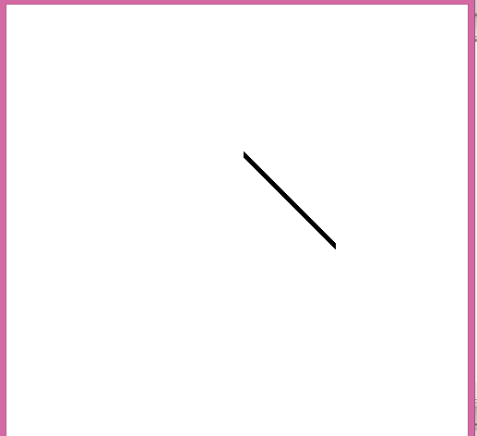

**2. Program to implement Mid Point Circle Algorithm. The radius should be specified by the user.**

#include <GL/glut.h>

#include <stdio.h>

float x ;

float y ;

float r;

void init()

{

glClearColor(0.0,0.0,0.0,0.0);

glClear(GL_COLOR_BUFFER_BIT);

glMatrixMode(GL_PROJECTION);

gluOrtho2D(-900,900,-900,900);

}

void writepixel(float x,float y)

{

glPointSize(5);

glBegin(GL_POINTS);

glColor3f(1.0,0.0,0.0);

glVertex2f(x,y);

glEnd();

glFlush();

}

void midpointcircle( )

{

x=0;

y=r;

double d=5.0/4.0-r;

writepixel(x,y);

while(y>x)

{

if(d<0)

d=d+2.0*x+3.0;

else

{

d=d+2.0*(x-y)+5.0;

y--;

}

x++;

writepixel(x,y);

writepixel(y,x);

writepixel(y,-x);

writepixel(x,-y);

writepixel(-x,-y);

writepixel(-y,-x);

writepixel(-y,x);

writepixel(-x,y);

glFlush();

}

}

int main(int argc,char *argv[])

{

printf("Enter the radius of the circle\n");

scanf("%f",&r);

glutInit(&argc,argv);

glutInitWindowSize(500,500);

glutCreateWindow("Midpoint Circle Algorithm");

init();

glutDisplayFunc(midpointcircle);

glutMainLoop();

return 0;

}

**OUT PUT**

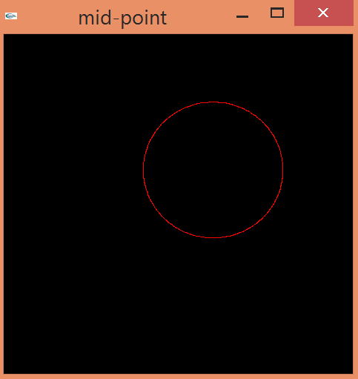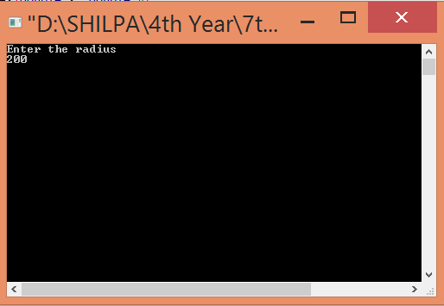

**3. Program to implement Liang-Barsky line clipping algorithm. Make provision to specify the input line, window for clipping and viewport for displaying the clipped image**.

#include<windows.h>

#include<stdio.h>

#include<GL/glut.h>

float xmin,ymin,xmax,ymax;

double xvmin=600,yvmin=600,xvmax=900,yvmax=900;

int x0,x1,y1,y0;

int cliptest(double p,double q,double *t1,double *t2)

{

double t=q/p;

if(p<0.0)

{

if(t>*t1) *t1=t;

if(t>*t2) return(false);

}

else

if(p>0.0)

{

if(t<*t2) *t2=t;

if(t<*t1) return(false);

}

else

if(p==0.0)

{

if(q<0.0) return(false);

}

return(true);

}

void LiangBarskyLineClipAndDraw(double x0,double y0,double x1,double y1)

{

double dx=x1-x0,dy=y1-y0,te=0.0,t1=1.0;

if(cliptest(-dx,x0-xmin,&te,&t1))

if(cliptest(dx,xmax-x0,&te,&t1))

if(cliptest(-dy,y0-ymin,&te,&t1))

if(cliptest(dy,ymax-y0,&te,&t1))

{

if(t1<1.0)

{

x1=x0+t1*dx;

y1=y0+t1*dy;

}

if(te>0.0)

{

x0=x0+te*dx;

y0=y0+te*dy;

}

double sx=(xvmax-xvmin)/(xmax-xmin);

double sy=(yvmax-yvmin)/(ymax-ymin);

double vx0=xvmin+(x0-xmin)*sx;

double vy0=yvmin+(y0-ymin)*sy;

double vx1=xvmin+(x1-xmin)*sx;

double vy1=yvmin+(y1-ymin)*sy;

glColor3f(1.0,0.0,0.0);

glBegin(GL_LINE_LOOP);

glVertex2f(xvmin,yvmin);

glVertex2f(xvmax,yvmin);

glVertex2f(xvmax,yvmax);

glVertex2f(xvmin,yvmax);

glEnd();

glColor3f(0.0,0.0,1.0);

glBegin(GL_LINES);

glVertex2d(vx0,vy0);

glVertex2d(vx1,vy1);

glEnd();

}

}

void drawrect()

{

glColor3f(0.0,0.0,1.0);

glBegin(GL_LINE_LOOP);

glVertex2f(xmin,ymin);

glVertex2f(xmax,ymin);

glVertex2f(xmax,ymax);

glVertex2f(xmin,ymax);

glEnd();

}

void drawline()

{

glColor3f(1.0,0.0,1.0);

glBegin(GL_LINES);

glVertex2d(x0,y0);

glVertex2d(x1,y1);

glEnd();

}

void display()

{

glClear(GL_COLOR_BUFFER_BIT);

drawline();

drawrect();

LiangBarskyLineClipAndDraw(x0,y0,x1,y1);

glFlush();

}

void myinit()

{

glClearColor(1.0,1.0,1.0,1.0);

glColor3f(1.0,0.0,0.0);

glPointSize(1.0);

glMatrixMode(GL_PROJECTION);

glLoadIdentity();

gluOrtho2D(0.0,1000.0,0.0,1000.0);

}

int main(int argc,char** argv)

{

printf("Enter the window coordinates:");

scanf("%f%f%f%f",&xmin,&ymin,&xmax,&ymax);

printf("Enter End Points:");

scanf("%d%d%d%d",&x0,&y0,&x1,&y1);

glutInit(&argc,argv);

glutInitDisplayMode(GLUT_SINGLE|GLUT_RGB);

glutInitWindowSize(500,500);

glutInitWindowPosition(0,0);

glutCreateWindow("LBLCA");

glutDisplayFunc(display);

myinit();

glutMainLoop();

return 0;

}// Try for input values 100,100,500,500;

**OUT PUT:**

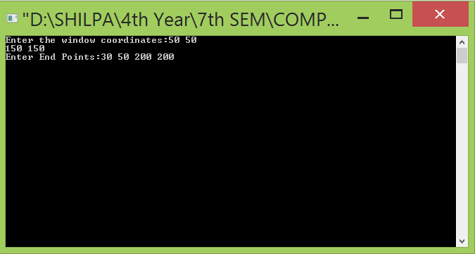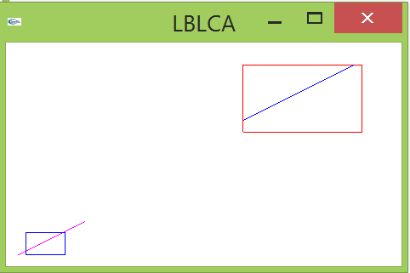

**4. Program to implement the Cohen-Sutherland line-clipping algorithm. Make provision to specify the input line, window for clipping and viewport for displaying the clipped image.**

#include<GL/glut.h>

#include <stdio.h>

#include <stdbool.h>

typedef int Outcode;

const int INSIDE=0;

const int LEFT=1;

const int RIGHT=2;

const int BOTTOM=4;

const int TOP=8;

double xmin=50,ymin=50,xmax=100,ymax=100;

void init()

{

glClearColor(1,2,3,1);

glClear(GL_COLOR_BUFFER_BIT);

glMatrixMode(GL_PROJECTION);

gluOrtho2D(0,500,0,500);

}

Outcode Computecode( double x, double y)

{

Outcode code=INSIDE;

if(x<xmin)

code|=LEFT;

else if(x>xmax)

code|=RIGHT;

else if(y<ymin)

code|=BOTTOM;

else if(y>ymax)

code|=TOP;

return code;

}

void CohenSutherlandline(double x0,double a,double x1,double b)

{

bool accept =false;

Outcode outcode0=Computecode(x0,a);

Outcode outcode1=Computecode(x1,b);

double x,y;

while(true)

{

if(!(outcode0|outcode1)){

accept =true;

break;

}

else if(outcode0 & outcode1)

{

break;

}

else

{

Outcode outcodeout =outcode0?outcode0:outcode1;

if(outcodeout & TOP)

{

x=x0 +(x1-x0)*(ymax-a)/(b-a);

y=ymax;

}

else if(outcodeout & BOTTOM)

{

x=x0+(x1-x0)*(ymin-a)/(b-a);

y=ymin;

}

else if(outcodeout & RIGHT)

{

y=a +(b-a)*(xmax-x0)/(x1-x0);

x=xmax;

}

else if(outcodeout & LEFT)

{

y=a +(b-a)*(xmin-x0)/(x1-x0);

x=xmin;

}

if(outcodeout == outcode0)

{

x0=x;

a=y;

outcode0=Computecode(x0,a);

}

else

{

x1=x;

b=y;

outcode1=Computecode(x1,b);

}

}

}

if(accept)

{

glColor3f(1.0,0.0,0.0);

glBegin(GL_LINE_LOOP);

glVertex2f(4*xmin,4*ymin);

glVertex2f(4*xmax,4*ymin);

glVertex2f(4*xmax,4*ymax);

glVertex2f(4*xmin,4*ymax);

glEnd();

glBegin(GL_LINES);

glVertex2f(4*x0,4*a);

glVertex2f(4*x1,4*b);

glEnd();

}

}

void display()

{

double x0=60,a=20,x1=80,b=120;

glBegin(GL_LINE_LOOP);

glColor3f(1.0,0.0,0.0);

glVertex2f(xmin,ymin);

glVertex2f(xmax,ymin);

glVertex2f(xmax,ymax);

glVertex2f(xmin,ymax);

glEnd();

glBegin(GL_LINES);

glVertex2f(x0,a);

glVertex2f(x1,b);

glEnd();

CohenSutherlandline(x0,a,x1,b);

glFlush();

}

int main(int argc, char **argv)

{

glutInit(&argc,argv);

glutInitWindowSize(800,800);

glutCreateWindow("Cohen Sutherland line clipping window");

init();

glutDisplayFunc(display);

glutMainLoop();

return 0;

}

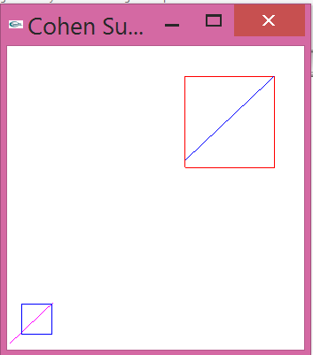**OUT P**

**5. Program to fill any given polygon using scan-line area filling algorithm. vertices for the polygon should be specified by the user.**

#include<windows.h>

#define BLACK 0

#include<stdlib.h>

#include<stdio.h>

#include<GL/glut.h>

float x1,x2,x3,x4,y1,y2,y3,y4;

void edgedetect(float x1,float y1,float x2,float y2,int *le,int *re)

{

float mx,x,temp;

int i;

if((y2-y1)<0)

{

temp=y1;

y1=y2;

y2=temp;

temp=x1;

x1=x2;

x2=temp;

}

if((y2-y1)!=0)

mx=(x2-x1)/(y2-y1);

else

mx=x2-x1;

x=x1;

for(i=y1;i<=y2;i++)

{

if(x<(float)le[i])

le[i]=(int)x;

if(x>(float)re[i])

re[i]=(int)x;

x+=mx;

}

}

void draw_pixel(int x,int y)

{

glColor3f(0.0,1.0,0.0);

glPointSize(3.0);

glBegin(GL_POINTS);

glVertex2i(x,y);

glEnd();

}

void scanfill(float x1,float y1,float x2,float y2,float x3,float y3,float x4,float y4)

{

int le[500],re[500];

int i,y;

for(i=0;i<500;i++)

{

le[i]=500;re[i]=0;

}

edgedetect(x1,y1,x2,y2,le,re);

edgedetect(x2,y2,x3,y3,le,re);

edgedetect(x3,y3,x4,y4,le,re);

edgedetect(x4,y4,x1,y1,le,re);

for(y=0;y<500;y++)

{

if(le[y]<=re[y])

for(i=(int)le[y];i<(int)re[y];i++)

{

draw_pixel(i,y);

Sleep(1);

glFlush();

}

}

}

void display()

{

x1=20.0;y1=20.0;x2=10.0;y2=30.0;x3=20.0;y3=40.0;x4=30.0;y4=30.0;

glClear(GL_COLOR_BUFFER_BIT);

glColor3f(0.0,0.0,1.0);

glBegin(GL_LINE_LOOP);

glVertex2f(x1,y1);

glVertex2f(x2,y2);

glVertex2f(x3,y3);

glVertex2f(x4,y4);

glEnd();

scanfill(x1,y1,x2,y2,x3,y3,x4,y4);

glFlush();

}

void myinit()

{

glClearColor(1.0,1.0,1.0,1.0);

glColor3f(1.0,0.0,0.0);

glPointSize(1.0);

glMatrixMode(GL_PROJECTION);

glLoadIdentity();

gluOrtho2D(0.0,50.0,0.0,50.0);

}

int main(int argc,char **argv)

{

glutInit(&argc,argv);

glutInitDisplayMode(GLUT_SINGLE|GLUT_RGB);

glutInitWindowSize(500,500);

glutInitWindowPosition(0,0);

glutCreateWindow("Filling a polygon using Scan-Line Algorithm");

glutDisplayFunc(display);

myinit();

glutMainLoop();

}

**OUT PUT**

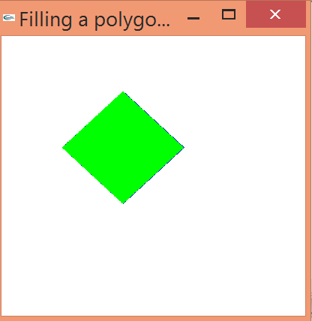

**6. Program to recursively subdivide a triangle to form 2D Sierpinski gasket. The number of recursive steps is to be specified by the user**

#include <windows.h>

#include <GL/glut.h>

#include <stdio.h>

int n;

void init()

{

glClearColor(1.0, 1.0, 1.0, 1.0);

glClear(GL_COLOR_BUFFER_BIT);

glMatrixMode(GL_PROJECTION);

gluOrtho2D(0, 10, 0, 10);

}

void triangle(float *a,float *b, float *c)

{

glVertex2f(a[0],a[1]);

glVertex2f(b[0],b[1]);

glVertex2f(c[0],c[1]);

}

void draw_triangle(float *a,float *b,float *c , int k)

{

float ab[2],ac[2],bc[2];

int i;

if(k>0)

{

for(i=0;i<2;i++)

ab[i]=(a[i]+b[i])/2;

for(i=0;i<2;i++)

bc[i]=(b[i]+c[i])/2;

for(i=0;i<2;i++)

ac[i]=(a[i]+c[i])/2;

draw_triangle(a,ab,ac,k-1);

draw_triangle(b,bc,ab,k-1);

draw_triangle(c,ac,bc,k-1);

}

else

{

triangle(a,b,c);

}

}

void display()

{

float a[2]={1,1};

float b[2]={6,1};

float c[2]={3.5,5};

glBegin(GL_TRIANGLES);

glColor3f(0,0,0);

draw_triangle(a,b,c,n);

glEnd();

glFlush();

}

int main(int argc, char** argv)

{

printf("enter n value");

scanf("%d",&n);

glutInit(&argc,argv);

glutInitWindowSize(500,500);

glutCreateWindow("Sierpinski Gasket");

init();

glutDisplayFunc(display);

glutMainLoop();

return 0;

}

OUT PUT

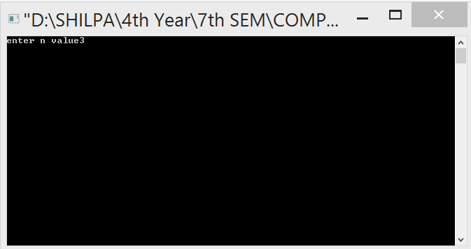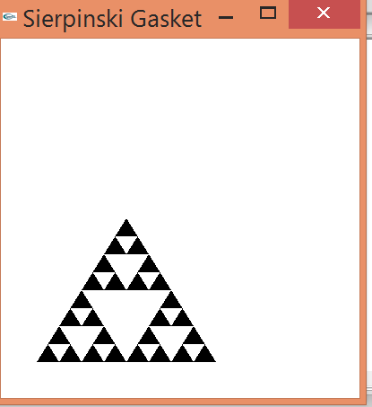

**7. Program to display a set of values {f(i, j)} as a rectangular mesh. Number of rows and columns for the mesh generation must be taken from the user.**

#include<windows.h>

#include<stdlib.h>

#include<GL/glut.h>

#define maxx 20

#define maxy 30

#define dx 10

#define dy 15

GLfloat x[maxx]={0.0},y[maxy]={0.0};

GLfloat x0=50,y0=50;

GLint i,j;

void init()

{

glClearColor(1.0,1.0,1.0,1.0);

glColor3f(1.0,0.0,0.0);

glPointSize(5.0);

glMatrixMode(GL_PROJECTION);

glLoadIdentity();

gluOrtho2D(0.0,499.0,0.0,499.0);

glutPostRedisplay();

}

void display(void)

{

glClear(GL_COLOR_BUFFER_BIT);

glColor3f(0.0,0.0,1.0);

for(i=0;i<maxx;i++)

x[i]=x0+i*dx;

for(j=0;j<maxy;j++)

y[j]=y0+j*dy;

glColor3f(0.0,0.0,1.0);

for(i=0;i<maxx-1;i++) // Filling mesh from bottom to top and left to right

for(j=0;j<maxy-1;j++)

{

glColor3f(0.0,0.0,1.0);

glBegin(GL_LINE_LOOP);

glVertex2f(x[i],y[j]);

glVertex2f(x[i],y[j+1]);

glVertex2f(x[i+1],y[j+1]);

glVertex2f(x[i+1],y[j]);

glEnd();

glFlush();

}

glFlush();

}

int main(int argc,char **argv)

{

glutInit(&argc,argv);

glutInitDisplayMode(GLUT_SINGLE|GLUT_RGB);

glutInitWindowSize(500,400);

glutInitWindowPosition(0,0);

glutCreateWindow("Rectangular Mesh");

glutDisplayFunc(display);

init();

glutMainLoop();

}

**OUT PUT**

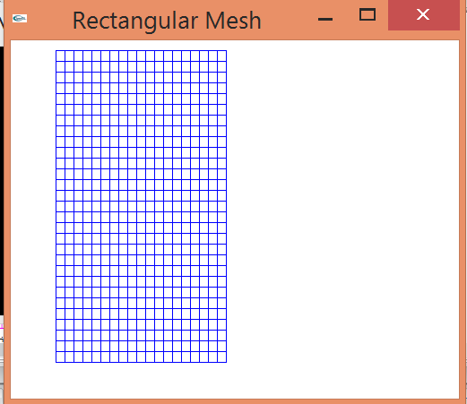

**8. Program to create a random figure and rotate it about a given fixed point using transformation matrices. Make provision for the user to enter pivot point for the rotation.**

#include<windows.h>

#include<stdio.h>

#include<math.h>

#include<GL/glut.h>

GLfloat house[2][9]={{100.0,100.0,175.0,250.0,250.0,150.0,150.0,200.0,200.0}, {100.0,300.0,400.0,300.0,100.0,100.0,150.0,150.0,100.0}};

GLfloat theta;

GLfloat h=100.0;

GLfloat k=100.0;

void drawhouse()

{

glColor3f(1.0,0.0,0.0);

glBegin(GL_LINE_LOOP);

glVertex2f(house[0][0],house[1][0]);

glVertex2f(house[0][1],house[1][1]);

glVertex2f(house[0][3],house[1][3]);

glVertex2f(house[0][4],house[1][4]);

glEnd();

glColor3f(1.0,0.0,1.0);

glBegin(GL_LINE_LOOP);

glVertex2f(house[0][5],house[1][5]);

glVertex2f(house[0][6],house[1][6]);

glVertex2f(house[0][7],house[1][7]);

glVertex2f(house[0][8],house[1][8]);

glEnd();

glColor3f(1.0,0.0,0.0);

glBegin(GL_LINE_LOOP);

glVertex2f(house[0][1],house[1][1]);

glVertex2f(house[0][2],house[1][2]);

glVertex2f(house[0][3],house[1][3]);

glEnd();

}

void display()

{

int i;

GLfloat m[16],p,q;

p=-h*(cos(theta)-1)+k*(sin(theta));

q=-k*(cos(theta)-1)-h*(sin(theta));

for(i=0;i<15;i++)

m[i]=0.0;

m[0]=cos(theta);

m[1]=sin(theta);

m[4]=-sin(theta);

m[5]=cos(theta);

m[12]=p;

m[13]=q;

m[10]=1;

m[15]=1;

glMatrixMode(GL_MODELVIEW);

glClear(GL_COLOR_BUFFER_BIT);

drawhouse();

glPushMatrix();

glMultMatrixf(m);

drawhouse();

glPopMatrix();

glFlush();

}

void myinit()

{

glClearColor(1.0,1.0,1.0,1.0);

glColor3f(1.0,1.0,0.0);

glMatrixMode(GL_PROJECTION);

glLoadIdentity();

gluOrtho2D(0.0,499.0,0.0,499.0);

glMatrixMode(GL_MODELVIEW);

}

int main(int argc,char **argv)

{

printf("enter the rotation angle\n");

scanf("%f",&theta);

theta=theta*3.141/180;

glutInit(&argc,argv);

glutInitDisplayMode(GLUT_SINGLE|GLUT_RGB);

glutInitWindowSize(500,500);

glutInitWindowPosition(0,0);

glutCreateWindow("rotated house");

glutDisplayFunc(display);

myinit();

glutMainLoop();

return 0;

}

**OUT PUT**

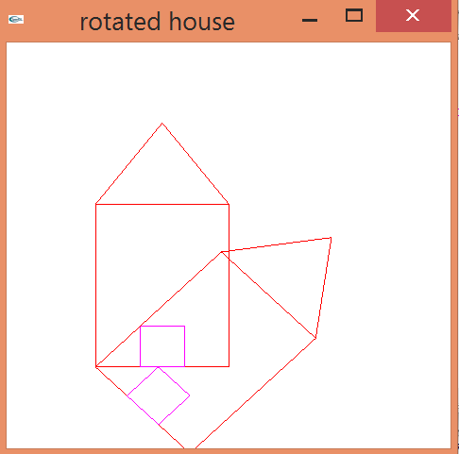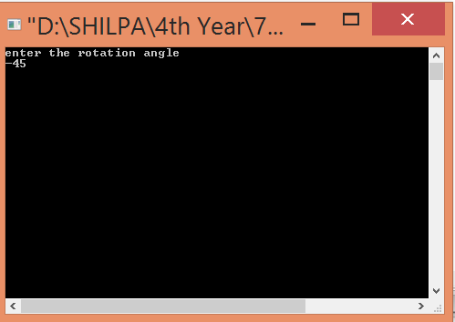

**9.Program to create a random object and to implement the suggested mouse and keyboard interactions through OpenGL function.**

#include<windows.h>

#include<GL/glut.h>

#include<stdio.h>

#include<math.h>

GLfloat wh=500, ww=500;

GLfloat size=10.0;

void init()

{

glClearColor(1,1,1,1);

glClear(GL_COLOR_BUFFER_BIT);

glColor3f(0,1,0);

glMatrixMode(GL_PROJECTION);

glLoadIdentity();

gluOrtho2D(0,ww,0,wh);

}

void myReshape(GLint w, GLint h)

{

glMatrixMode(GL_PROJECTION);

glLoadIdentity();

gluOrtho2D(0,double(w),0,double(h));

glMatrixMode(GL_MODELVIEW);

glLoadIdentity();

glViewport(0,0,w,h);

ww=w;

wh=h;

}

void draw(int x, int y)

{

glClearColor(1,1,1,1);

glClear(GL_COLOR_BUFFER_BIT);

y=wh-y;

glBegin(GL_POLYGON);

glVertex2f(x+size, y+size);

glVertex2f(x-size, y+size);

glVertex2f(x-size, y-size);

glVertex2f(x+size, y-size);

glEnd();

glFlush();

}

void mymouse(int btn, int state, int x, int y)

{

if(btn==GLUT_RIGHT_BUTTON && state== GLUT_DOWN)

draw(x,y);

}

void display()

{

glClearColor(1,0,0,0);

glClear(GL_COLOR_BUFFER_BIT);

glFlush();

}

int main(int argc, char ** argv)

{

glutInit(&argc, argv);

glutInitDisplayMode(GLUT_SINGLE |GLUT_RGB);

glutInitWindowSize(wh,ww);

glutInitWindowPosition(0,0);

glutCreateWindow("NITTE");

init();

glutDisplayFunc(display);

glutMouseFunc(mymouse);

glutReshapeFunc(myReshape);

glutMainLoop();

}

**OUT PUT**

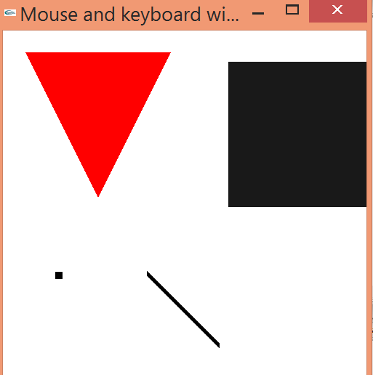

**10. Program to draw a color cube and spin it using OpenGL transformation matrices along x, y and z axes.**

#include<windows.h>

#include<stdlib.h>

#include<GL/glut.h>

#include<stdio.h>

GLfloat vertices[][3]={{-1.0,-1.0,-1.0},{1.0,-1.0,-1.0},{1.0,1.0,-1.0},

{-1.0,1.0,-1.0},{-1.0,-1.0,1.0},{1.0,-1.0,1.0},{1.0,1.0,1.0},{-1.0,1.0,1.0}};

GLfloat normals[][3]={{-1.0,-1.0,-1.0},{1.0,-1.0,1.0},{1.0,1.0,-1.0},

{-1.0,1.0,-1.0},{-1.0,-1.0,1.0},{1.0,-1.0,1.0},{1.0,1.0,1.0},{-1.0,1.0,1.0}};

GLfloat colors[][3]={{0.0,0.0,0.0},{1.0,0.0,0.0},{1.0,1.0,0.0},{0.0,1.0,0.0},

{0.0,0.0,1.0},{1.0,0.0,1.0},{1.0,1.0,1.0},{0.0,1.0,1.0}};

void polygon(int a,int b,int c,int d)

{

glBegin(GL_POLYGON);

glColor3fv(colors[a]);

glNormal3fv(normals[a]);

glVertex3fv(vertices[a]);

glColor3fv(colors[b]);

glNormal3fv(normals[b]);

glVertex3fv(vertices[b]);

glColor3fv(colors[c]);

glNormal3fv(normals[c]);

glVertex3fv(vertices[c]);

glColor3fv(colors[d]);

glNormal3fv(normals[d]);

glVertex3fv(vertices[d]);

glEnd();

}

void colorcube(void)

{

polygon(0,3,2,1);

polygon(2,3,7,6);

polygon(0,4,7,3);

polygon(1,2,7,6);

polygon(4,5,6,7);

polygon(0,1,5,4);

}

static GLfloat theta[]={0.0,0.0,0.0};

static GLint axis=2;

void display(void)

{

glClear(GL_COLOR_BUFFER_BIT|GL_DEPTH_BUFFER_BIT);

glLoadIdentity();

glRotatef(theta[0],1.0,0.0,0.0);

glRotatef(theta[1],0.0,1.0,0.0);

glRotatef(theta[2],0.0,0.0,1.0);

colorcube();

glFlush();

glutSwapBuffers();

}

void spinCube()

{

theta[axis]+=1.0;

if(theta[axis]>360.0) theta[axis]-=360.0;

glutPostRedisplay();

}

void mouse(int btn,int state,int x,int y)

{

if(btn==GLUT_LEFT_BUTTON&&state==GLUT_DOWN)axis=0;

if(btn==GLUT_MIDDLE_BUTTON&&state==GLUT_DOWN)axis=1;

if(btn==GLUT_RIGHT_BUTTON&&state==GLUT_DOWN)axis=2;

}

void myReshape(int w,int h)

{

glViewport(0,0,w,h);

glMatrixMode(GL_PROJECTION);

glLoadIdentity();

if(w<=h)

glOrtho(-2.0,2.0,-2.0*(GLfloat)h/(GLfloat)w,2.0*(GLfloat)h/(GLfloat)w,-10.0,10.0);

else

glOrtho(-2.0*(GLfloat)w/(GLfloat)h,2.0*(GLfloat)w/(GLfloat)h,-2.0,2.0,-10.0,10.0);

glMatrixMode(GL_MODELVIEW);

}

int main(int argc,char **argv)

{

glutInit(&argc,argv);

glutInitDisplayMode(GLUT_DOUBLE|GLUT_RGB|GLUT_DEPTH);

glutInitWindowSize(500,500);

glutCreateWindow("Rotating a color cube");

glutReshapeFunc(myReshape);

glutDisplayFunc(display);

glutIdleFunc(spinCube);

glutMouseFunc(mouse);

glEnable(GL_DEPTH_TEST);

glutMainLoop();

}

**OUT PUT**

